In March 2017, 24 PhD students came to ICMS for a four day Modelling Camp to apply their mathematical skills to realistic problems. Modelling Camps are excellent preparation for attending Study Groups where mathematicians collaborate with industry, analysing and solving real problems.
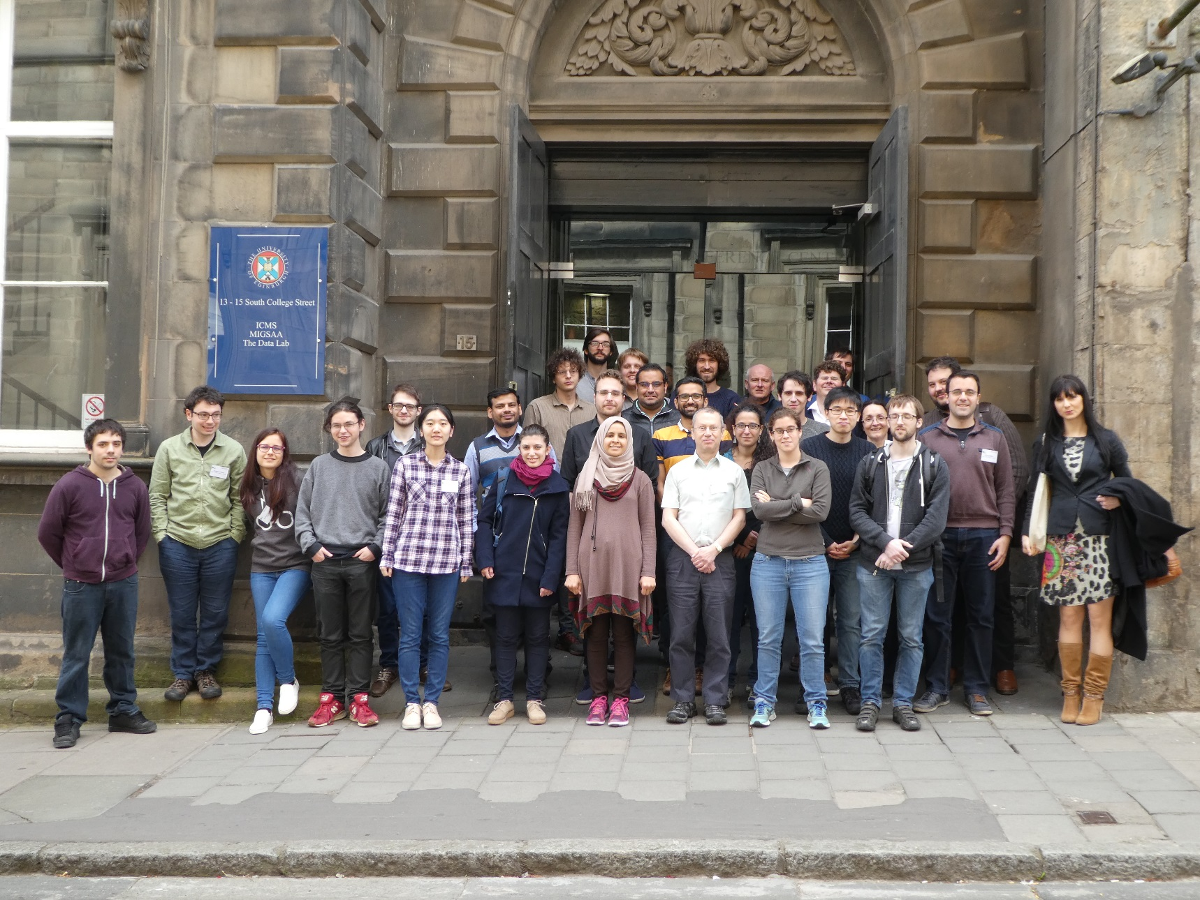
Students and Instructors at the 2017 Modelling Camp
Following a structure akin to the Study Groups, students formed into small groups after a morning listening to four problem descriptions from four problem setters. For the ICMS Camp we had a variety of topics for the students to get to grips with:
- Bottle Testing
- Laser Scintillation
- Ink Jet Head
- Marine Acquisition Technology

Once the students were matched with appropriate problems, the remaining days predominantly involved group working under the guidance of the problem instructors. Each group presented regular updates on progress to the others and there was a final presentation on the last morning. Photos below, show each group after their final presentation with their hard earned chocolate oranges!

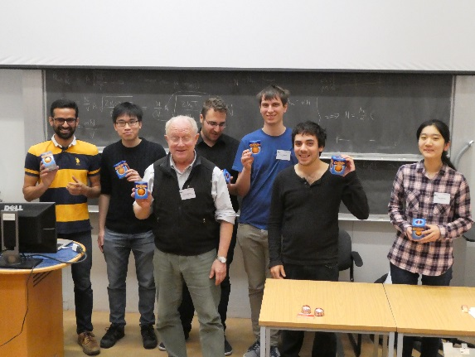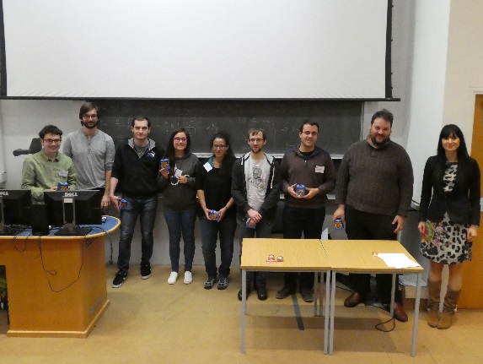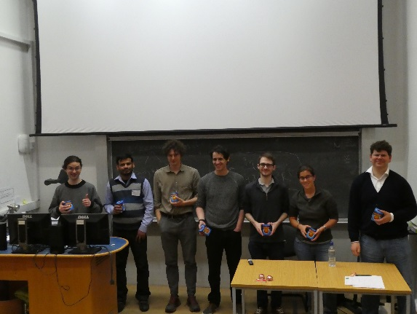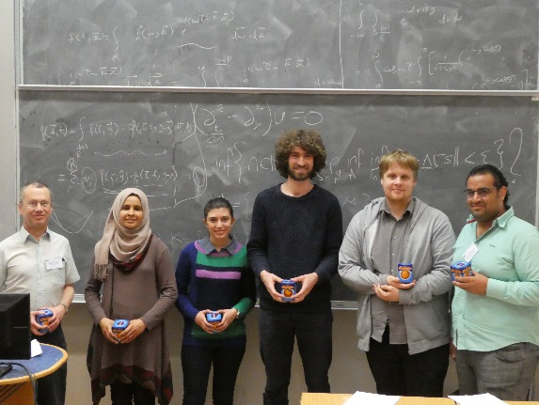
Problem Groups after final presentations, from left Bottle testing, Laser Scinitillations, Ink Jet Head, Marine Acquisition Technology
There was lots of lively discussion and blackboards were in great demand! A prize for the best team was awarded on the final day. More photos are available on our flickr stream.

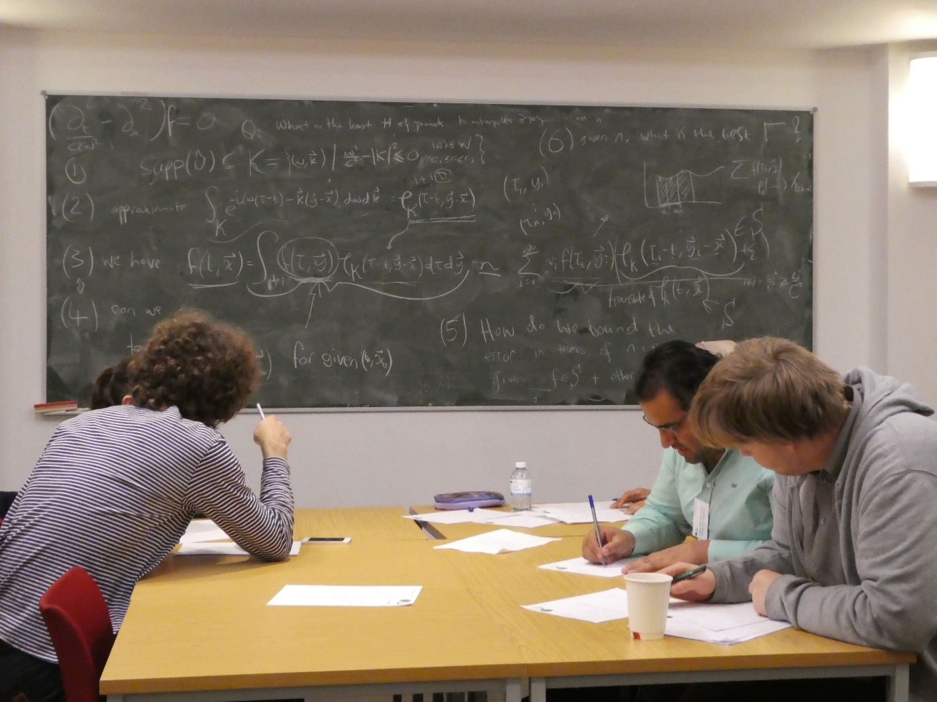
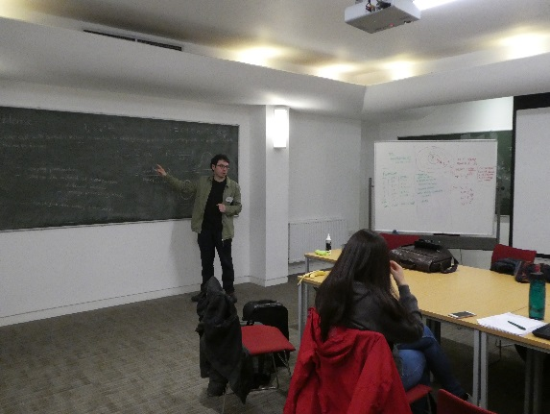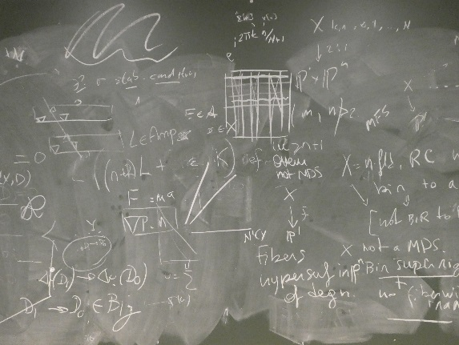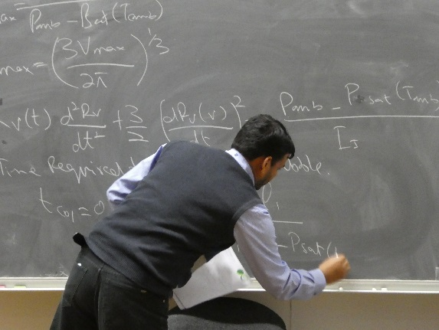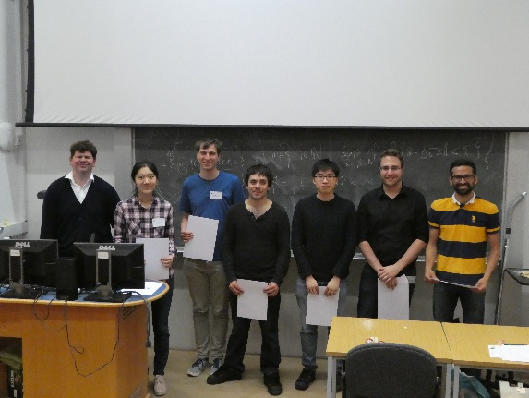
Photos of blackboard use during Modelling camp and winning group (Bottle Testing)

Read more about the ICMS Modelling Camp in our interviews with two of the participants.

Mohsin Javed, University of Oxford
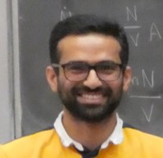

Tell me about today's event and your role in it:
I am here at the ICMS modelling camp and our group is trying to solve an industrial problem. We are six PhD students from 5 different countries and we are all working together and having a lot of fun. I don't have a particular role but as a relatively senior PhD student, I am taking a lead on various aspects of modelling the problem and eventually creating simulations.

What problem are your working on, and how have you found it?
Our mission is to reduce the number of false rejections in a factory which produces air tight bottles. In the present mechanism, quite a few bottles are initially rejected which turn out to be fine on a second examination. We want to considerably reduce the number of initial false rejections without introducing too many cases where a bad bottle is accepted.

Is the maths similar, or different, from your own research?
The maths is quite different from my own research. I work in approximation theory but this problem is very much in the domain of fluids, statistical estimation and machine learning.

What do you think is the main benefit of taking part?
I am moving into the industry after my PhD so for me it's a wonderful opportunity to get a sense of the problems encountered in real life and in real time. It's also extremely important to be able to work with people who do not necessarily have the same technical and cultural background as you do and this modelling camp is a great place to develop social skills to collaborate with a diverse group of people.

Do you have any advice for first-time Modelling Camp Participants?
Don't hesitate to put yourself out of your comfort zone. You might feel a strong sense of belonging to one particular problem while all others might seem quite foreign to your own work. My advice is to try something new. You will be surprised to see how much you can learn in a short time! And there is no such fun like learning something new.

If you could solve one maths problem, what would it be?
Seriously? Ok, in that case, the Reimann hypothesis. But wait, that's too easy. A much harder problem is to develop the perfect mathematical model for an economic system which eradicates poverty and makes this world a better place. I think this is perhaps less satisfying mathematically than the Reimann hypothesis but will certainly have a bigger positive impact on the world.

Do you have any thoughts regarding how we can raise the profile of maths?
I think it's already quite high! But sometimes in a negative way, and let me explain why. The moment you tell someone that you are doing a degree in mathematics, people are in awe of your intelligence and (quite rightly?) think that you are a geek who lives in a world of numbers and equations far far away from the "real world". Mathematics needs a better PR management than this. Mathematics trains you to think in a very coherent and logical way. In that spirit, mathematics perhaps is very close to law. Mathematicians are also great problem solvers and these days they are contributing to almost every branch of science, medicine, engineering, economics, social science and even neuroscience and politics. We need the world to know about this. We need to communicate this better.

Do you have any thought on how diversity in mathematics can be improved?
Mathematics tends to be polarising as a subject, especially for kids when they are very young and for boys and girls when they are in their teens. There is this notion in our society that either you are very good at mathematics or you are very bad at it. We have to make sure that a reasonable amount of mathematics is available and accessible for everyone. And I do not think that we lack the resources to do so. I think the problem is that most of us are growing with a binary sense of either a strong belonging or that of complete estrangement to mathematics. We can work on this.

Who is your favourite mathematician and why?
Cauchy, because my favourite equation is called Cauchy's integral formula

Najlaa Alalwan, University of Strathclyde
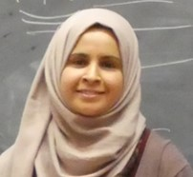

Tell me about today's event and your role in it:
I am one of the participants of the workshop. The participants are mathematical researchers from UK and other countries. They are supported by the workshop to come to discus and try to find solution for some real world applications.

What problem are your working on, and how have you found it?
What problem are your working on, and how have you found it? I am working on gradient problem, which was about modelling a discrete points to a continuous function and finding the approximated number of points to this function with less error.

Is the maths similar, or different, from your own research?
It was completely different, where I am working in graph theory.

What do you think is the main benefit of taking part?
Since I am working on different area of mathematics, I do not know anything about modelling and I always met students working in modelling. So I liked to know what is modelling.

Do you have any advice for first-time Modelling Camp Participants?
If they want to get good results in few days, then they should choose the problem that related with their own work.

Do you have any thoughts regarding how we can raise the profile of maths?
I think that could be done when the work is based on collaboration with engineering sector to be much more applicable in real world application.

Do you have any thought on how diversity in mathematics can be improved?
I think that could be done by increase these workshops to include different areas of mathematics.

Who is your favourite mathematician and why?
I suppose my supervisor Prof. Ernesto Estrada. He is brilliant in how analyse the mathematics to be applicable in real world applications.

ICMS gratefully acknowledge the financial contribution from MI-NET and MIGSAA CDT towards this event. MI-NET is funded by COST through the EU Framework Programme Horizon 2020. The support of Leonardo, UK and Schlumberger with the provision of problems and guidance/support for students is appreciated.

